**Software** **Requirements Specification**

**for**

Janwar – An Online Pet Marketplace

**Version 1.0 approved**

**Prepared by :**

**Hasnain Fatmi (21L-1773)**

**Mehdy Hasnain (21L-1784)**

**Umair Bin Asim (21L-1847)**

**Team Lead : Hasnain Fatmi (21L-1773)**

**Date: 31st March 2024**

**Table of Contents**

**Table of Contents ii**

**Revision History ii**

**1. Introduction 1**

1.1 Purpose 1

1.2 Document Conventions 1

1.3 Intended Audience and Reading Suggestions 1

1.4 Product Scope 1

1.5 References 1

**2. Overall Description 2**

2.1 Product Perspective 2

2.2 Product Functions 2

2.3 User Classes and Characteristics 2

2.4 Operating Environment 2

2.5 Design and Implementation Constraints 2

2.6 User Documentation 2

2.7 Assumptions and Dependencies 3

**3. External Interface Requirements 3**

3.1 User Interfaces 3

3.2 Hardware Interfaces 3

3.3 Software Interfaces 3

3.4 Communications Interfaces 3

**4. System Features 4**

**5. Other Nonfunctional Requirements 13**

5.1 Performance Requirements 13

5.2 Scalability Requirements 13

5.3 Security Requirements 13

5.4 Reliability Requirements 13

5.5 Compatibility Requirements 13

5.6 Maintainability Requirements 13

5.7 Usability Requirements 14

5.8 Data Integrity Requirements 14

**6. Other Requirements 14**

6.1 Safety Requirements 14

6.2 Documentation Requirements 14

**Appendix A: Glossary 14**

**Appendix B: Analysis Models 15**

**Appendix C: To Be Determined List 23**

**Revision History**

| **Name** | **Date** | **Reason For Changes** | **Version** |
| --- | --- | --- | --- |
|  |  |  |  |
|  |  |  |  |

# **Introduction**

## **Purpose**

This Software Requirements Specification (SRS) document outlines the requirements for the development of an online platform facilitating the buying, selling, and adoption of pets and pet-related accessories. The project aims to provide a user-friendly and efficient system for users to engage in transactions related to pets and accessories securely.

## **Document Conventions**

This document follows standard SRS conventions with numbered sections for easy reference. Requirements are presented in a structured format with clear headings and descriptions.

## **Intended Audience and Reading Suggestions**

This document is intended for developers, project managers, designers, testers, and stakeholders involved in the development and implementation of the pet trading platform. Readers are advised to start with the overview sections to gain an understanding of the project scope and then delve into specific sections relevant to their roles or interests.

## **Product Scope**

The software described in this document encompasses a comprehensive platform for users to register, browse pets and accessories, make transactions, update profiles, and manage disputes. The platform aims to facilitate seamless interactions between buyers, sellers, adopters, and administrators in the pet trading domain and strives to make it easier for pet lovers to acquire their desired pets with ease.

## **References**

* *This website is inspired from websites such as* [*Ebay*](https://www.ebay.com/)*,* [*OLX*](https://www.olx.com.pk/) *and* [*Daraz*](https://www.daraz.pk/)*. Hence, May find it helpful by visiting these websites to get some info on what this website encompasses*

# **Overall Description**

## **Product Perspective**

The pet trading platform is a standalone system designed to provide a centralized marketplace for pet-related transactions. It may interface with external systems for payment processing and communication purposes.

## **Product Functions**

* *User registration and authentication*
* *Pet and accessory browsing*
* *Transaction management*
* *Profile updating*
* *Dispute resolution*
* *Feedback and complaints*

## **User Classes and Characteristics**

User classes include buyers, sellers, adopters, and administrators. Each class may have varying levels of technical expertise and interaction frequency with the platform.

## **Operating Environment**

The platform operates in a web-based environment, compatible with common web browsers and operating systems. It interfaces with databases and external APIs for data storage and functionality.

## **Design and Implementation Constraints**

Constraints include compliance with regulatory policies, hardware limitations, integration with external systems, and adherence to security standards. Customers will be responsible for software maintenance or extra charges may be applied.

## **User Documentation**

User documentation components include user manuals, on-line help, and tutorials will be provided alongside the software after implementation. Documentation formats adhere to industry standards.

## **Assumptions and Dependencies**

Assumptions include availability of third-party components, stability of the development environment, and compliance with regulatory requirements. Dependencies may include external APIs and libraries.

# **External Interface Requirements**

## **User Interfaces**

The system features intuitive user interfaces for registration, browsing pets and accessories, conducting transactions, and managing profiles. Interfaces adhere to established GUI standards and include error message display standards.

## **Hardware Interfaces**

The system is fundamentally software-centric and does not have any direct relation with the hardware side.

## **Software Interfaces**

The system is primarily a web app with NodeJS as the backend and ReactJS as the frontend, primarily based on the MERN stack. The version of NodeJS being used is 16.13. The operating system used for development is Microsoft Windows 11. However, since it is a web app, the operating system on the user’s device is not as much of a concern as long as it can successfully run web browsers, which it is extremely unlikely for an operating system used nowadays to be not able to do.

## **Communications Interfaces**

Communication functions include email notifications, web browser interactions, and network server communications. Communication standards such as HTTPS are utilized, with provisions for security.

# **System Features**

## 4.1.1 User Registration and Profiles

## Description and Priority: This feature enables users to create accounts with profiles to manage their listings and interactions. It is of High priority as it forms the foundation of user engagement on the platform.

## 4.1.2 Stimulus/Response Sequences:

## Stimulus: User accesses the platform for the first time.

## Response: System displays the option to register a new account.

## Stimulus: User selects the registration option.

## Response: System prompts user to input required registration details.

## Stimulus: User submits registration form.

## Response: System verifies the information and creates a new user profile.

## 4.1.3 Functional Requirements:

## The system shall provide a registration form with fields for username, email address, password, and additional optional profile information.

## The system shall validate the uniqueness of usernames and email addresses to prevent duplicate accounts.

## Upon successful registration, the system shall automatically log the user into their account.

## The system shall allow users to edit and update their profile information at any time.

## The system shall allow users to upload a profile picture/avatar.

## 

## 4.2 Browse and Buy Pets

## Description and Priority: This feature enables users to purchase pets of various species and breeds listed on the platform. It is of High priority as it is a primary function of the system.

## 4.2.1 Stimulus/Response Sequences:

## Stimulus: User browses available pets for sale.

## Response: System displays a list of pets with details such as species, breed, age, price, and seller information.

## Stimulus: User selects a pet for purchase.

## Response: System Displays the details of the pet Owner and the contact information of the pet owner

## 4.2.2 Functional Requirements:

## The system shall display detailed information for each pet listing, including photos, description, price, seller information, and contact details.

## The system shall allow users to filter pet listings based on criteria such as species, breed, age, location, and price range.

## The system shall update inventory levels and remove sold pets from listings upon successful purchase.

## The system shall provide users with the option to rate and review sellers after completing a purchase.

## The system shall provide customer support channels for resolving issues related to purchases.

## 

## 4.3 Browse and Adopt Pet

## Description and Priority: This feature allows users to adopt pets of various species and breeds listed for adoption. It is of High priority as it promotes pet adoption and rescue efforts.

## 4.3.1 Stimulus/Response Sequences:

## Stimulus: User browses available pets for adoption.

## Response: System displays a list of pets with details such as species, breed, age, adoption requirements, and contact information.

## Stimulus: User selects a pet for adoption.

## Response: System Provides contact information of the organization/individual who currently caretaking of the pet.

## 4.3.2 Functional Requirements:

## The system shall provide a searchable database of pets available for adoption, categorized by species, breed, and other relevant attributes.

## The system shall display detailed information for each pet listing, including photos, description, contact information.

## The system shall allow users to filter pet listings based on criteria such as species, breed, age, location, and adoption suitability.

## The system shall notify rescue organizations or individuals of adoption inquiries and provide contact information for follow-up.

## The system shall facilitate communication between adopters and rescuers to coordinate adoption logistics and arrangements.

## The system shall update pet listings to indicate adoption status (e.g., pending, adopted) and remove adopted pets from listings.

## .

## 4.4 List Adoption Pets

## Description and Priority: This feature enables rescue organizations and individuals to list pets for adoption on the platform. It is of High priority as it facilitates the adoption process and helps pets find new homes.

## 4.4.1 Stimulus/Response Sequences:

## Stimulus: Rescue organization or individual accesses the platform.

## Response: System displays the option to post an ad for pet adoption.

## Stimulus: User selects the option to post an adoption ad.

## Response: System prompts user to input details of the pet for adoption.

## Stimulus: User submits the details of the pet.

## Response: System displays a confirmation message and lists the ad on the platform.

## 4.4.2 Functional Requirements:

## The system shall provide a form for users to input details of the pet available for adoption, including species, breed, age, gender, photos, and description.

## The system shall validate the input fields to ensure completeness and accuracy.

## The system shall allow users to specify adoption requirements and preferences for potential adopters.

## The system shall allow users to upload multiple photos of the pet for adoption.

## Upon submission, the system shall store the adoption ad in the database with a unique identifier.

## The system shall allow users to edit or delete their posted adoption ads as needed.

## The system shall display posted adoption ads to other users for viewing and adoption inquiries.

## 4.5 List Selling Pets

## Description and Priority: This feature enables users to list pets for sale on the platform. It is of High priority as it facilitates pet transactions and commerce.

## 4.5.1 Stimulus/Response Sequences:

## Stimulus: User accesses the platform

## Response: System displays the option to post an ad for selling a pet.

## Stimulus: User selects the option to post a selling ad.

## Response: System prompts user to input details of the pet for sale.

## Stimulus: User submits the details of the pet.

## Response: System displays a confirmation message and lists the ad for selling on the platform.

## 4.5.2 Functional Requirements:

## The system shall provide a form for users to input details of the pet available for sale, including species, breed, age, gender, photos, and description.

## The system shall validate the input fields to ensure completeness and accuracy.

## The system shall provide options for users to upload multiple photos of the pet for sale.

## The system shall provide a preview functionality for users to review their selling ad before submission.

## Upon submission, the system shall store the selling ad in the database with a unique identifier.

## The system shall allow users to edit or delete their posted selling ads as needed.

## The system shall display posted selling ads to other users for viewing and purchase inquiries.

## 

## 4.6 Buy Accessories

## Description and Priority: This feature allows users to purchase pet accessories from a separate section of the platform. It is of High priority as it complements the pet buying and adoption functionalities.

## 4.6.1 Stimulus/Response Sequences:

## Stimulus: User navigates to the accessories section of the platform.

## Response: System displays a catalog of available pet accessories.

## Stimulus: User selects an accessory for purchase.

## Response: System prompts user to add the accessory to the shopping cart.

## Stimulus: User confirms the purchase and proceeds to checkout.

## Response: System processes the payment and notifies the user of successful purchase.

## 4.6.2 Functional Requirements:

## The system shall provide a separate section for users to browse and purchase pet accessories.

## The system shall categorize accessories based on type (e.g., toys, beds, grooming supplies).

## The system shall display detailed information for each accessory listing, including photos, description, price, and availability.

## The system shall allow users to filter accessory listings based on criteria such as type, price range, and brand.

## The system shall provide shopping cart functionality for users to add multiple accessories for purchase.

## The system shall calculate and display the total cost including taxes and any additional fees.

## The system shall integrate with secure payment gateways to process transactions securely.

## The system shall generate and send purchase confirmation emails to users.

## The system shall update inventory levels and remove sold accessories from listings upon successful purchase.

## 4.7 Secure Transactions

## Description and Priority: This feature ensures the integration of secure payment gateways for transactions by users. It is of High priority as it is critical for maintaining trust and security on the platform.

## 4.7.1 Stimulus/Response Sequences:

## Stimulus: User initiates a purchase or adoption process.

## Response: System prompts user to select a payment method and enter payment details.

## Stimulus: User submits payment information.

## Response: System encrypts the payment data and processes the transaction securely.

## Stimulus: Payment is processed successfully.

## Response: System notifies the user of successful payment and updates the relevant records.

## 4.7.2 Functional Requirements:

## The system shall integrate with reputable third-party payment gateways (e.g., PayPal, Stripe) to process transactions securely.

## The system shall encrypt sensitive payment information during transmission to prevent unauthorized access.

## The system shall provide users with multiple payment options (e.g., credit/debit cards, digital wallets) for flexibility.

## The system shall display clear and transparent pricing information, including total cost and any additional fees, during the checkout process.

## The system shall securely store transaction records and payment history for auditing and reconciliation purposes.

## The system shall provide users with the option to save payment methods for future transactions (optional feature).

## The system shall notify users of any payment-related errors or issues and provide guidance for resolution.

## 

## 4.8 Search and Filter Options

## Description and Priority: This feature enables users to easily search and find pets for adoption, pets for sale, or accessories based on their preferences. It is of medium priority as it enhances user experience and facilitates efficient navigation.

## 4.8.1 Stimulus/Response Sequences:

## Stimulus: User enters search criteria or selects filtering options.

## Response: System displays search results or filtered listings based on the specified criteria.

## Stimulus: User refines or adjusts search/filter settings.

## Response: System updates the displayed results accordingly.

## 4.8.2 Functional Requirements:

## The system shall provide a search bar prominently displayed on the platform for users to enter keywords or phrases.

## The system shall allow users to filter search results or listings based on various criteria.

## The system shall support advanced search functionalities.

## The system shall display relevant suggestions or auto-complete options as users type in the search bar.

## The system shall prioritize and display matching results based on relevance and user preferences.

## The system shall provide sorting options for search results (e.g., by price, date listed, popularity).

## The system shall dynamically update search results or listings as users apply filters or refine search criteria.

## 

## 4.9 Feedback Mechanism

## Description and Priority: This feature allows users to provide feedback, report issues, and suggest improvements to the platform. It is of medium priority as it promotes user engagement and helps in enhancing the overall user experience.

## 4.9.1 Stimulus/Response Sequences:

## Stimulus: User accesses the feedback or support section of the platform.

## Response: System displays options for providing feedback, reporting issues, or submitting suggestions.

## Stimulus: User selects a feedback option and provides input.

## Response: System acknowledges receipt of feedback and may provide a confirmation message.

## 4.9.2 Functional Requirements:

## The system shall provide multiple channels for users to submit feedback, including forms, surveys, and direct messaging.

## The system shall categorize feedback types (e.g., general feedback, bug reports, feature requests) for efficient handling and tracking.

## The system shall provide acknowledgment messages or notifications to users upon successful submission of feedback.

## The system shall route feedback submissions to appropriate channels or personnel for review and action.

## The system shall prioritize and address critical or urgent feedback (e.g., security vulnerabilities, system outages) promptly.

## The system shall encourage users to provide constructive feedback by acknowledging and rewarding valuable contributions (optional feature).

## The system shall maintain confidentiality and privacy of user feedback, adhering to applicable data protection regulations.

## 

## 4.10 Manage Listing

## Description and Priority: This feature provides administrators with access to supervise and manage posts made by users. It is of High priority as it ensures the quality and integrity of listings on the platform.

## 4.10.1 Stimulus/Response Sequences:

## Stimulus: Administrator accesses the Admin Dashboard.

## Response: System displays options for managing user listings, including editing, deleting, or flagging for review.

## Stimulus: Administrator selects a listing for management.

## Response: System presents options for editing or deleting the selected listing.

## 4.10.2 Functional Requirements:

## The system shall provide an administrative dashboard or interface for managing user listings.

## The system shall allow administrators to view all active listings posted by users.

## The system shall provide search and filtering functionalities for administrators to locate specific listings based on criteria such as user ID, pet type, or date posted.

## The system shall allow administrators to edit or update listing details, including descriptions, prices, and images, as necessary.

## The system shall enable administrators to remove or delete listings that violate platform policies or are deemed inappropriate.

## The system shall log all actions taken by administrators related to listing management for auditing and accountability purposes.

## The system shall send notifications or alerts to administrators for new listings or listings requiring attention.

## 

## 4.11 List Accessories

## Description and Priority: This feature enables administrators to list accessories for users to purchase. It is of High priority as it expands the product offerings on the platform and enhances user engagement.

## 4.11.1 Stimulus/Response Sequences:

## Stimulus: Administrator accesses the accessories management interface.

## Response: System displays options for adding new accessories to the platform.

## Stimulus: Administrator selects the option to add a new accessory.

## Response: System prompts administrator to input details of the accessory, including name, description, price, and images.

## Stimulus: Administrator submits the accessory details.

## Response: System adds the accessory to the platform and updates the catalog.

## 4.11.2 Functional Requirements:

## The system shall provide an administrative interface for managing pet accessories.

## The system shall allow administrators to add, edit, or remove accessories from the catalog.

## The system shall require administrators to input details for each accessory, including name, description, price, and images.

## The system shall validate the input fields to ensure completeness and accuracy of accessory details.

## The system shall provide options for administrators to categorize accessories based on type (e.g., toys, beds, grooming supplies).

## The system shall allow administrators to set availability status for each accessory (e.g., in stock, out of stock).

## The system shall integrate new accessories seamlessly into the platform's shopping and checkout process.

# 

# 

# **Other Nonfunctional Requirements**

**5.1 Performance Requirements:**  
*The platform should have a response time of 3 seconds under a normal load of user interactions passed. The operations involving pet listings, searches, and transactions must be streamlined and performed with the best*

**5.2 Scalability Requirements:**  
*The system should have a scalability feature in handling more and more users, listings, and transactions rate without significant performance degradation.*  
  
 **5.3 Security Requirements:**

* ***User authentication****: The system shall implement secure authentication mechanisms such as password hashing and salting.*
* ***Access control****: Administrators should have access to sensitive functions and data, while regular users should have restricted access.*

**5.4 Reliability Requirements:**  
 *Platform should be up and running 24/7, allowing the least possible downtime of 99% (After It is shifted from Local Host).* **5.5 Compatibility Requirements:**  
*The web application should be supported on the latest versions of all major web browsers including Google Chrome, Mozilla Firefox. It has to adapt to all the different devices and screens (desktops, laptops, tablets, etc.) with easy navigation no matter the size.*  
  
 **5.6 Maintainability Requirements:**  
 *It is necessary to structure the code and to well-document it to be convenient for the maintenance and development.*

**5.7 Usability Requirements:**  
 *The User interface should be really easy to operate and it must be in a clear way, with instructions for each feature as well.*

**5.8 Data Integrity Requirements:**  
*This platform should incorporate data validation rules to exclude not only wrong data but also malicious information. User profile and listing changes, as well as transaction should be secured.*

# **Other Requirements**

***6.1 Safety Requirements* Requirements*:***

*The system shall not store sensitive user information such as passwords in plain text format. Payment transactions shall be conducted securely using encryption protocols to prevent unauthorized access.*

***6.2 Documentation Requirements:***

*Comprehensive user manuals and documentation shall be provided to guide users on platform usage and features. Developer documentation shall include system architecture, API documentation, and coding standards for future development and maintenance.*

**Appendix A: Glossary**

* ***Buyer****: A user who intends to purchase pets or accessories from the platform.*
* ***Seller****: A user who intends to sell pets through the platform.*
* ***Adopter****: A user who intends to adopt pets from the platform.*
* ***Administrator****: A user with elevated privileges responsible for managing the platform, including dispute resolution and user management.*
* ***Transaction****: The process of buying or selling pets or accessories on the platform.*
* ***Profile****: User account information containing personal details and preferences.*
* ***Dispute****: A disagreement or conflict between users regarding transactions or issues on the platform.*
* ***Pet****: An animal available for sale or adoption on the platform.*
* ***Accessory****: A product related to pet care or ownership available for sale on the platform.*

**Appendix B: Analysis Models**

1. **Use Case Diagram:**

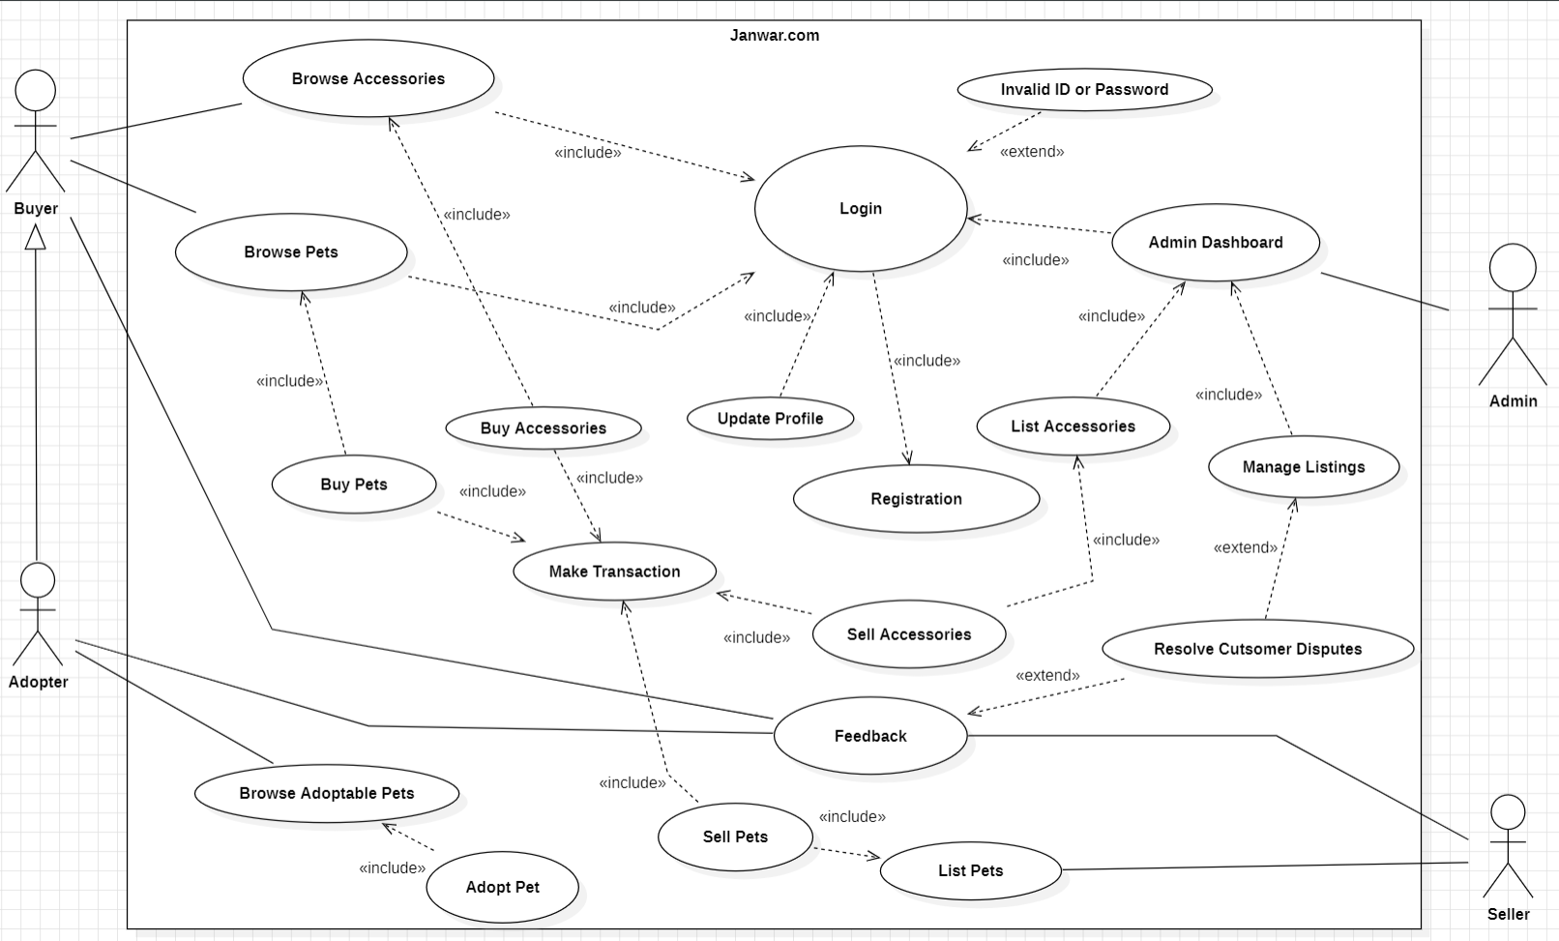

1. **Analysis Class Diagram:**

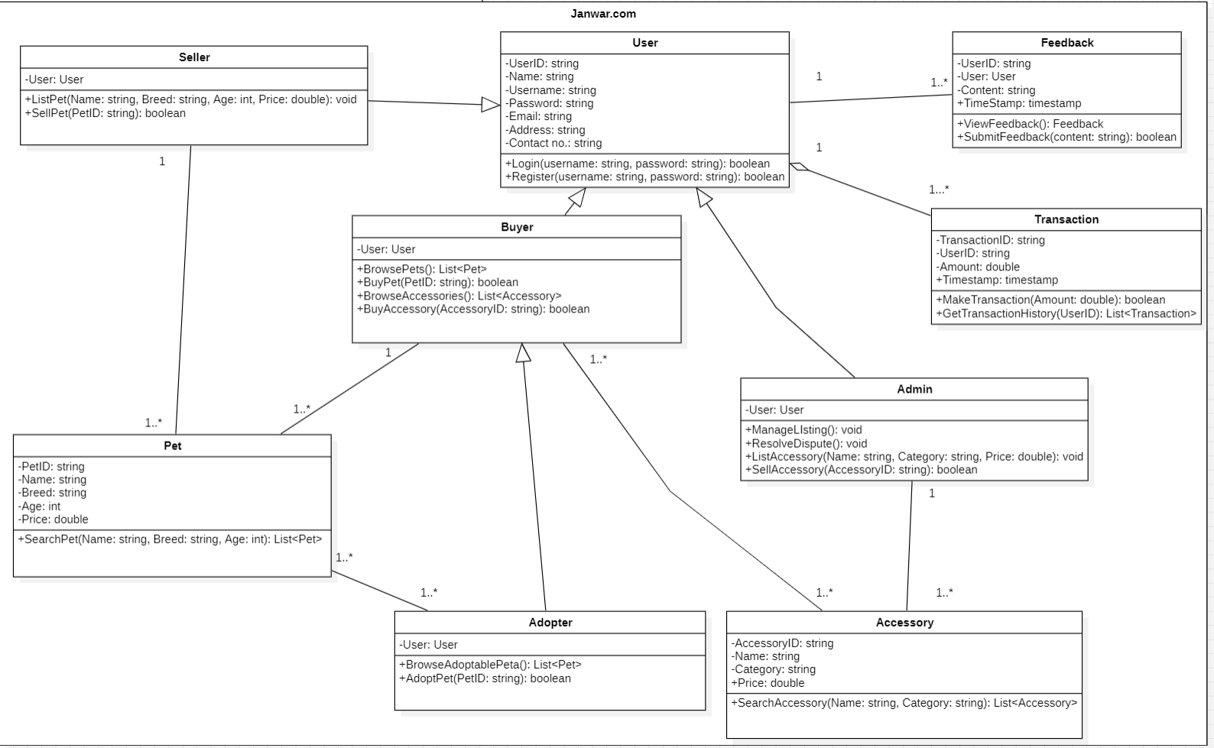

1. **Data Flow Diagram:**

* **Level 0:**

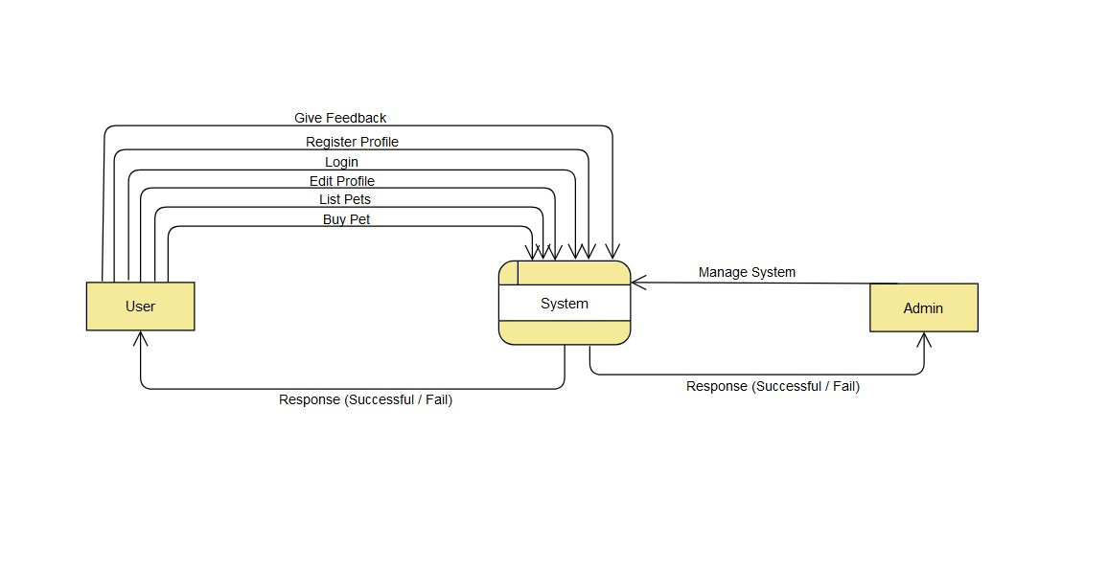

* **Level 1:**

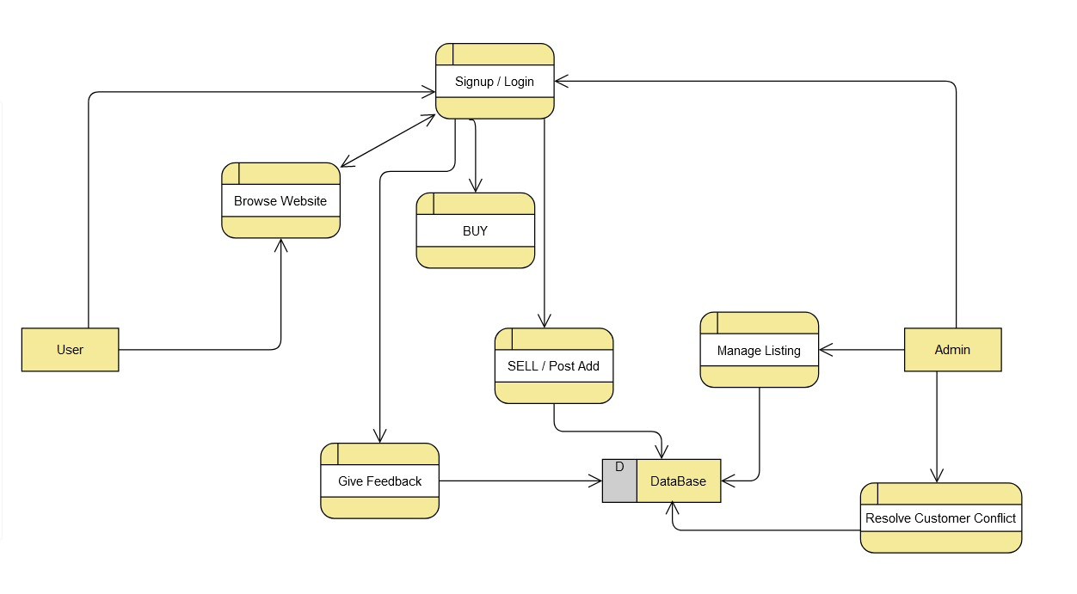

* **Level 2:**

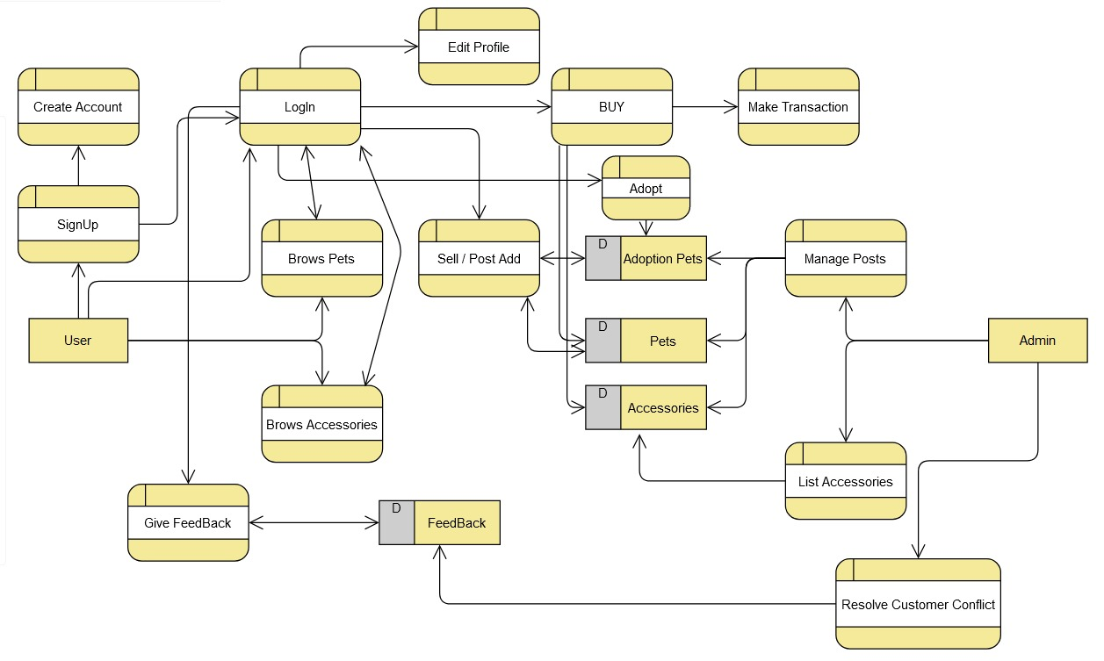

1. **Sequence Diagram:**

* **Register:**

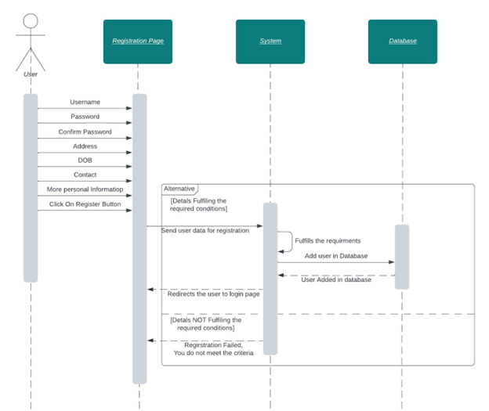

* **Login:**

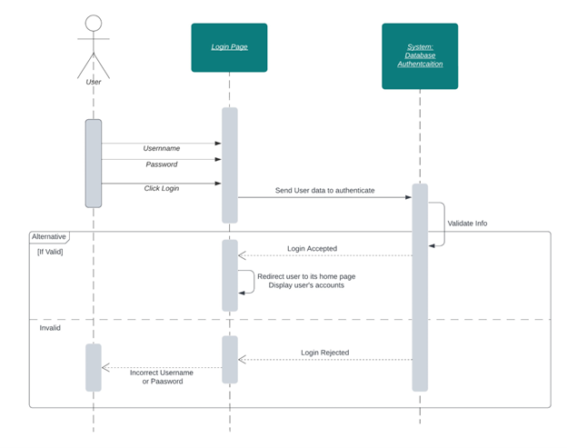

* **Admin Dashboard:**

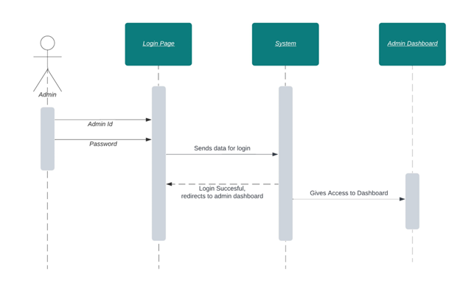

* **Feedback and Complaint:**

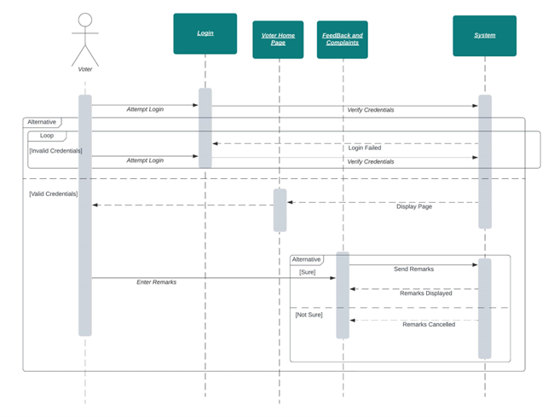

* **Invalid password or Id:**

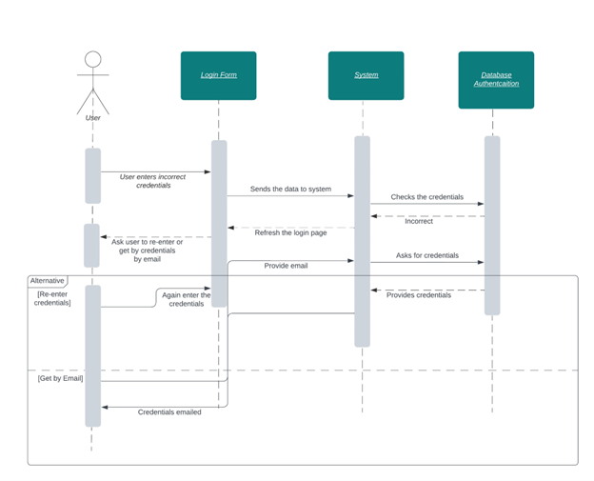

**Appendix C: To Be Determined List**

*1.* ***Payment Gateway Integration:*** *The specific payment gateway(s) to be integrated with the platform need(s) to be determined based on factors such as transaction fees, security features, and compatibility with the target market.*

*2.* ***User Authentication Mechanism:*** *The authentication method(s) to be employed, such as username/password, social login, or multi-factor authentication, should be decided based on security requirements and user convenience.*

*3.* ***Dispute Resolution Workflow:*** *A detailed workflow for managing disputes between users, including escalation procedures and communication protocols, needs to be established to ensure fair and efficient resolution.*

*4.* ***Third-Party Integration Requirements:*** *Any third-party services or APIs to be integrated with the platform, such as shipping services or inventory management systems, need to be identified and evaluated for compatibility and functionality.*